Zadatak 01.

[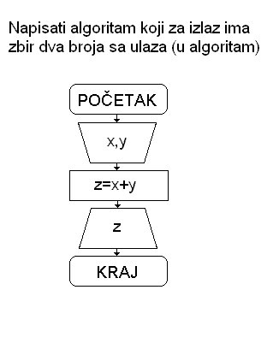](https://sites.google.com/site/dragoljubperisic/trecaalgzad001.bmp/trecaalgzad001-full;init:.bmp)

Zadatak 02.

[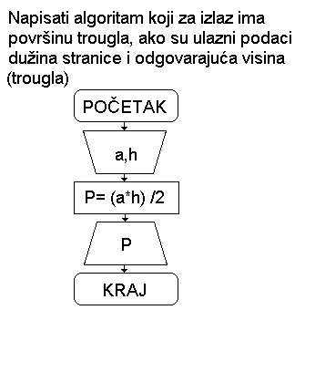](https://sites.google.com/site/dragoljubperisic/trecaalgzad002.bmp/trecaalgzad002-full;init:.bmp)

Zadatak 03.

[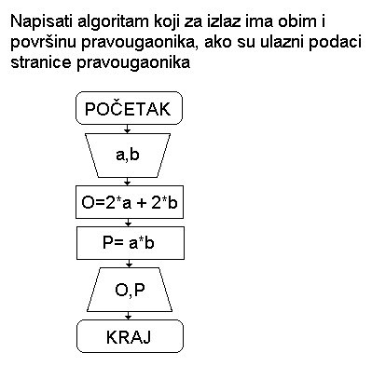](https://sites.google.com/site/dragoljubperisic/trecaalgzad003.bmp/trecaalgzad003-full;init:.bmp)

Zadatak 04.

[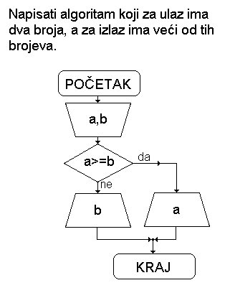](https://sites.google.com/site/dragoljubperisic/trecaalgzad004.bmp/trecaalgzad004-full;init:.bmp)

Zadatak 05.

[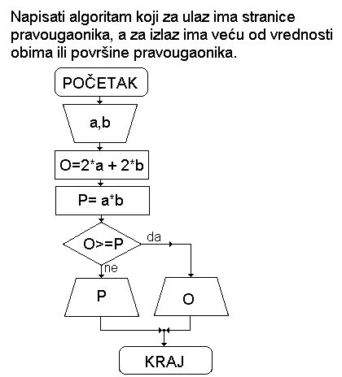](https://sites.google.com/site/dragoljubperisic/trecaalgzad005.bmp/trecaalgzad005-full;init:.bmp)